**What is docker?**

Docker (dock worker) is used to create containers which is standard way of packaging any application

**What is docker image?**

If the application can be developed in any sever by the standard way of packaging

### Docker installation

To install docker there are two components.

Docker client

To interact with docker engine to use command lines

Docker engine

In this three components are there

Orchestration

It is used for docker working in multi system.

Docker daemon

It gives a way to communication.

Runtime

It runs the low level activities.

Installation of docker in VM 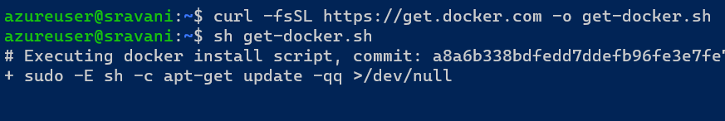

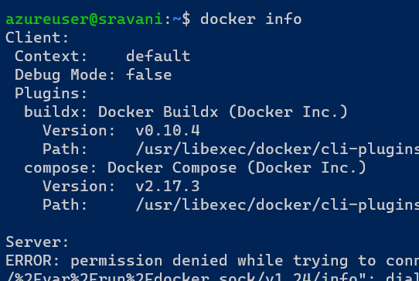

By observing above client is working but server is not working to work the sever to give the following command

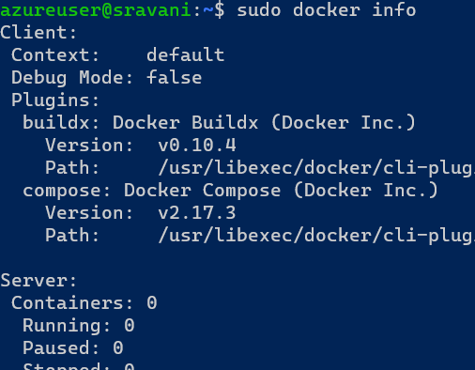

Every time sudo is good so switch to user into docker

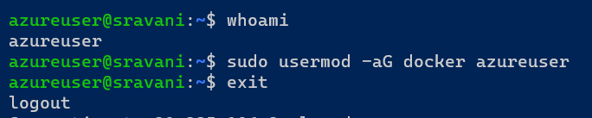

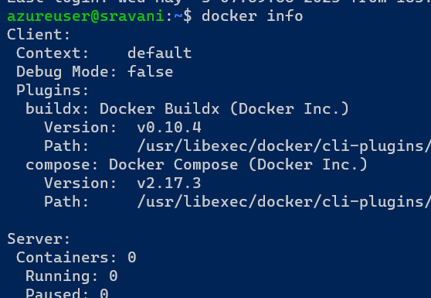

To check the docker working or not it’s a small example

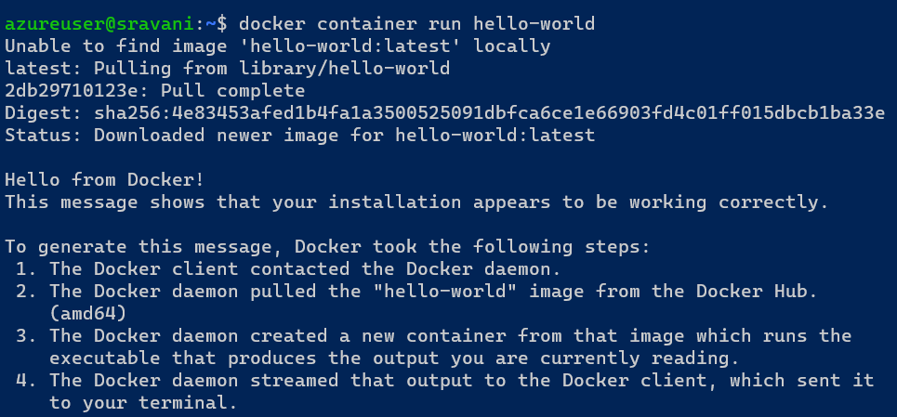

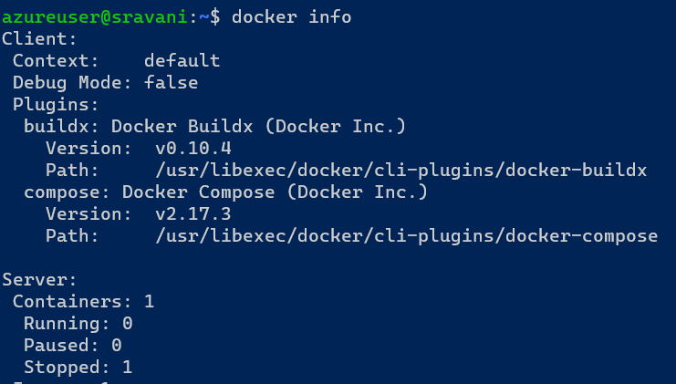



Check the docker image size

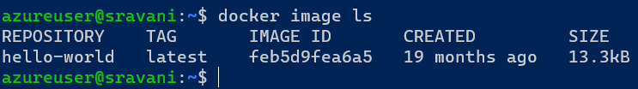

To see the status of disk by using command “htop”

CPU, Memory and other we will see the below

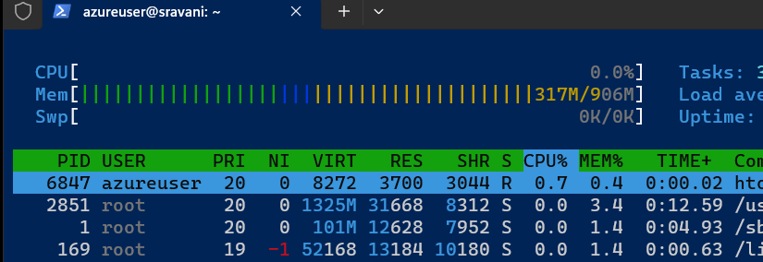

To see the network interface

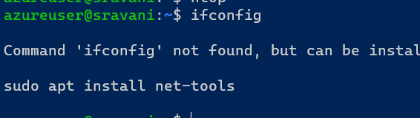

Now update the tools

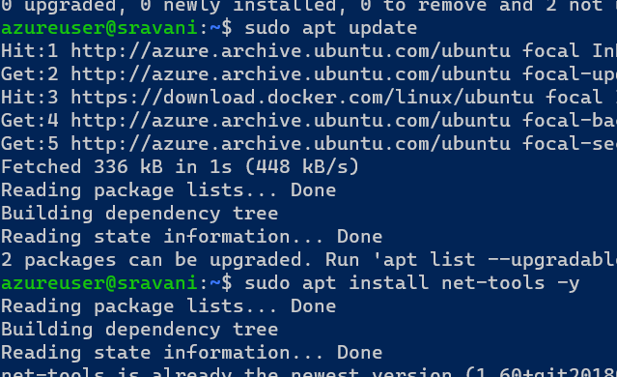

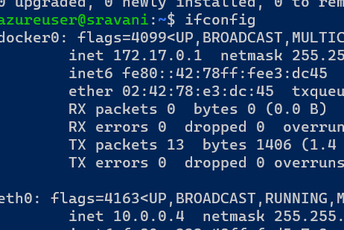

To search java

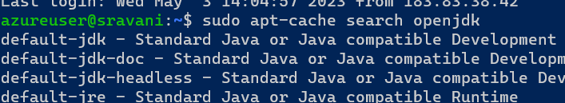

To install java

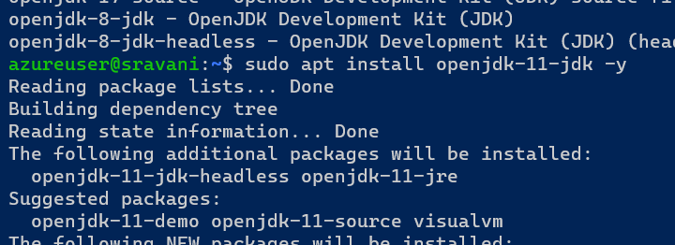

Similarly search and install dotnet and python also

To check version

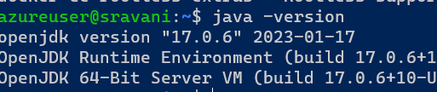

To install tomcat

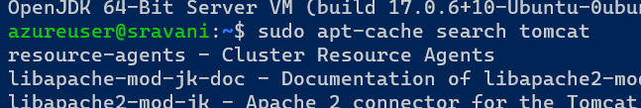

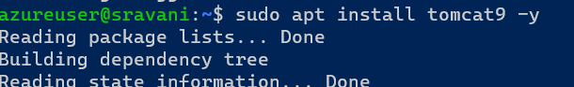

Here change the port to 8080 because tomcat port is 8080

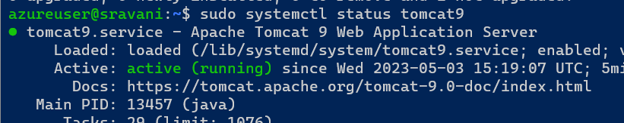

To go to google and enter ipaddress:port

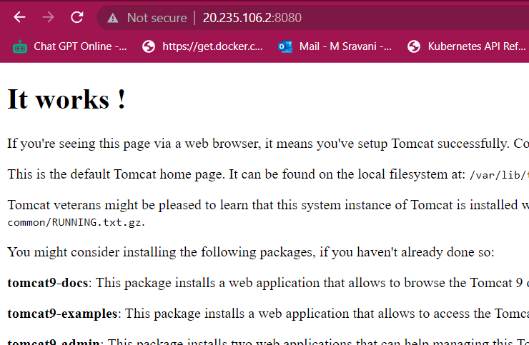

Connecting to docker playground

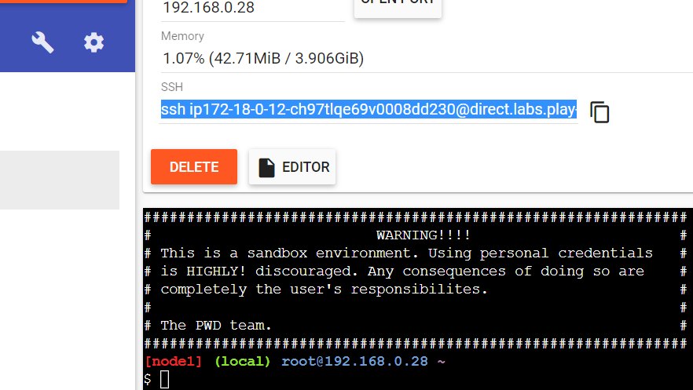

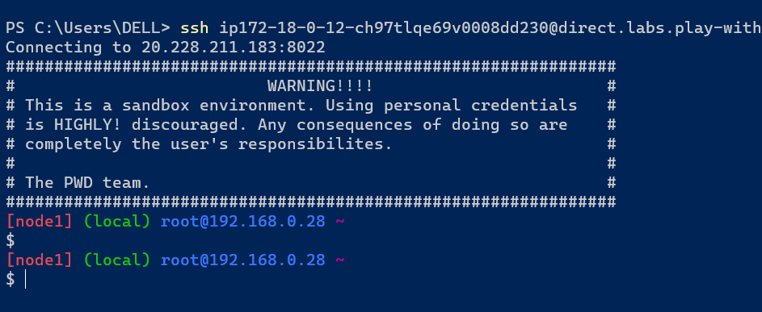

To run the container

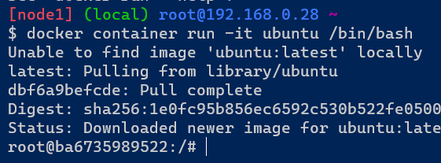

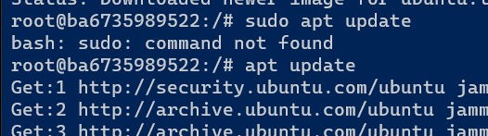

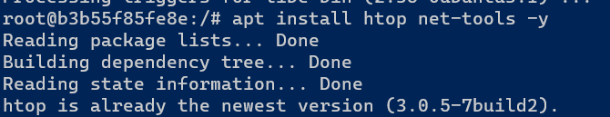

To see the status of disk by using command “htop”

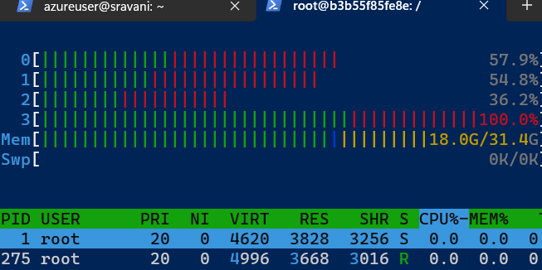

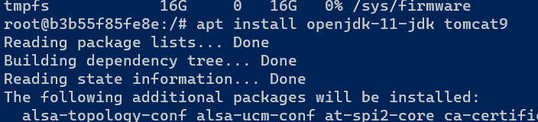

To check the tomcat9 status

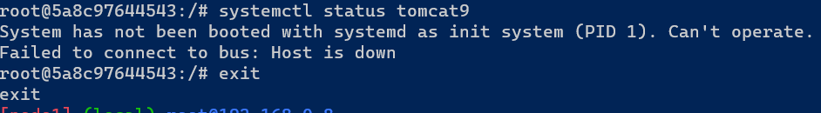

The host is down then what we do

To pull the image or create

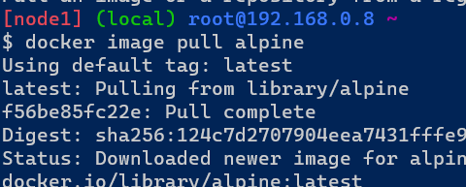

To check the size of image

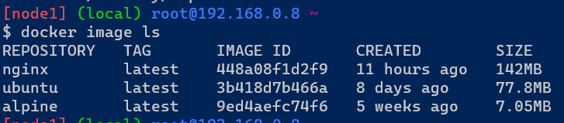

To create docker container it getting following components

new process tree

disk mounts

network (nic)

cpu/memory

Users

##

**### DOCKER ARCHITECTURE**

Generation 1:

Docker client send the request to docker daemon were commands interact with docker.It has to be relay on to create lxc (Linux)container.this internally uses name spaces and c groups.It is inbuilt kernel is Linux.

Generation 2:

In this generation updating kernels and frequently creates lib containers.lib container is docker component. It has own code to run the applications.Libc directly speak with kernel.

Generation 3:

In this generation docker client specks with docker daemon.Docker daemon expose api and it speaks with containerd. This containerd creates container by any container technology that is OCI. The containerd speaks with runc.

### Run hello-world docker container and observe the container status

Docker client send to the request to docker daemon. Docker daemon checks the image and create the container by using local repository.



Docker container status





Check the docker images and also write down the size of hello-world image



To add user to the docker group

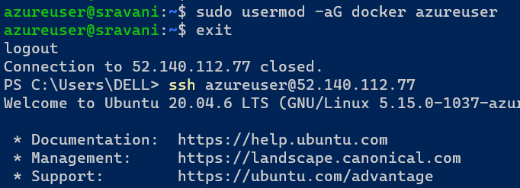

Now check the version

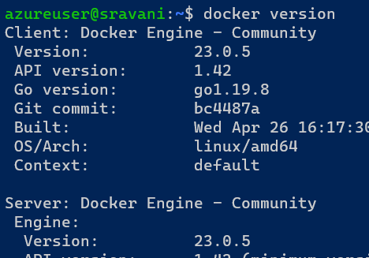

To check the images

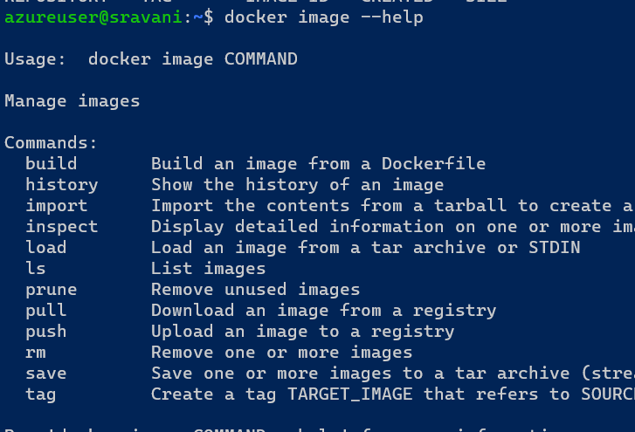

Similarly docker container, docker network, docker compose.

To pull the image

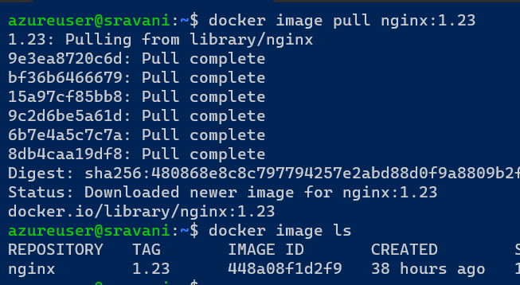

To pull the image “ docker image pull <image name> “

To see the all images in docker container by using “ docker image ls “ command.

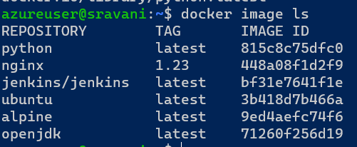

To remove all images “ docker image rm <image name> “

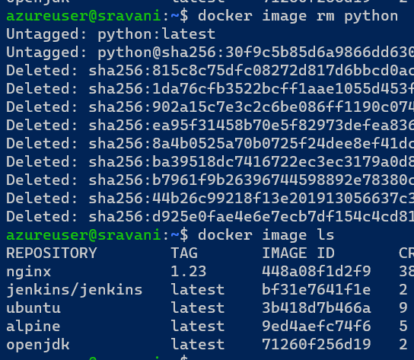

To check the image ids.

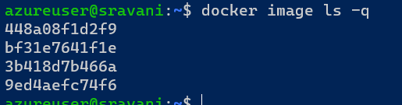

To remove all docker images

docker image rm $(docker image ls -q)

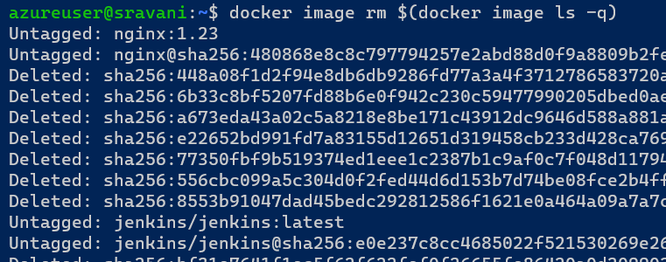

To create a container

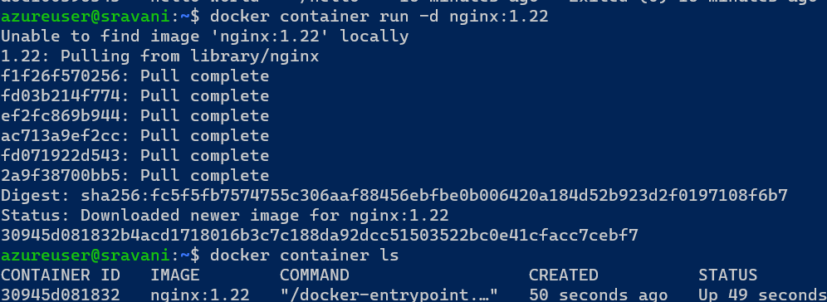

To remove the container

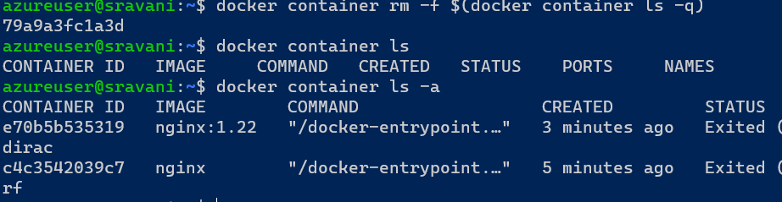

### **Docker lifecycle**

Docker lifecycle has 6 states they are

Create

Run

Stop

Pause

Unpause

Delete

Above states explained with example below

To create and run

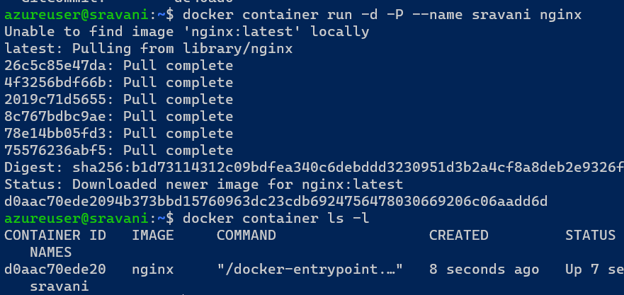

To stop

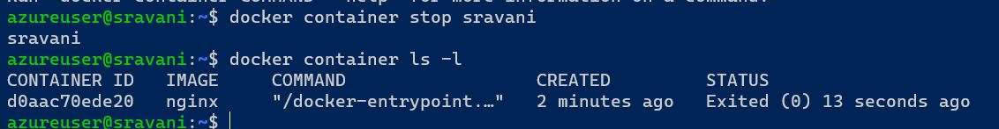

To start

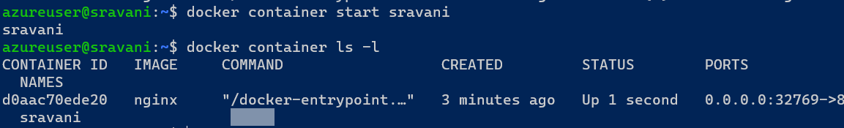

To pause

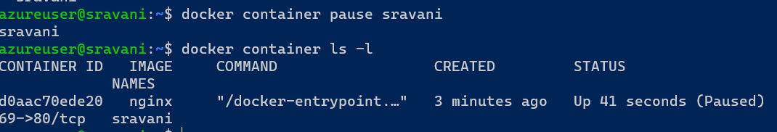

To Unpause

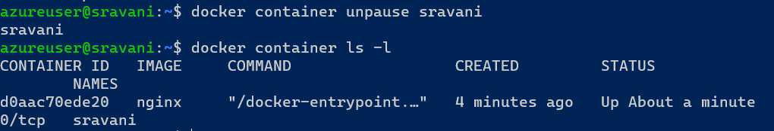

To delete

If container I running it is not possible to delete so we will stop the container and delete

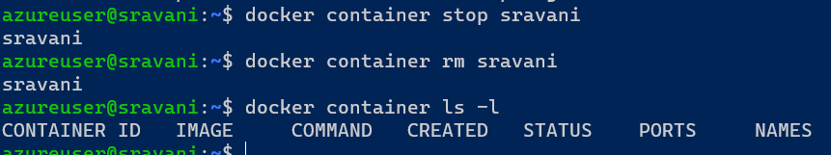

To run the container by using host port by using this command

command: docker container run -d -p <host-port>:<container-port><image name>

Ex: Create nginx container and expose port 8080

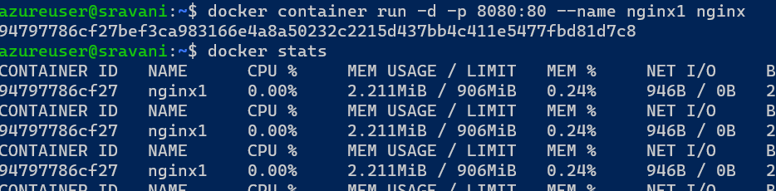

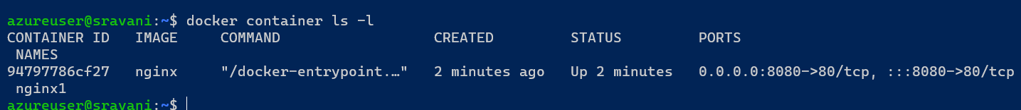

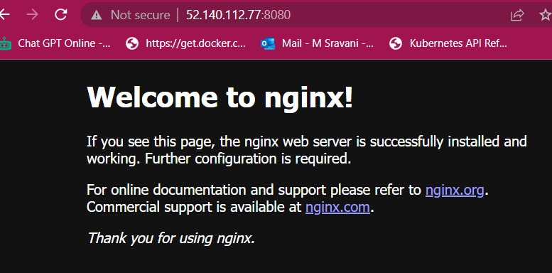

### **Exercise**

1. Install docker on a linux vm
2. Run 1 httpd containers (apache container) which runs on 80 port
3. try accessing any application
4. stop the containers
5. try accessing
6. start the continers and access this should work
7. pause the containers, access the application
8. unpause the containers, access the application
9. delete the container

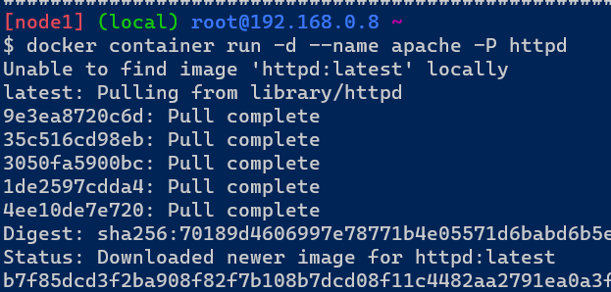

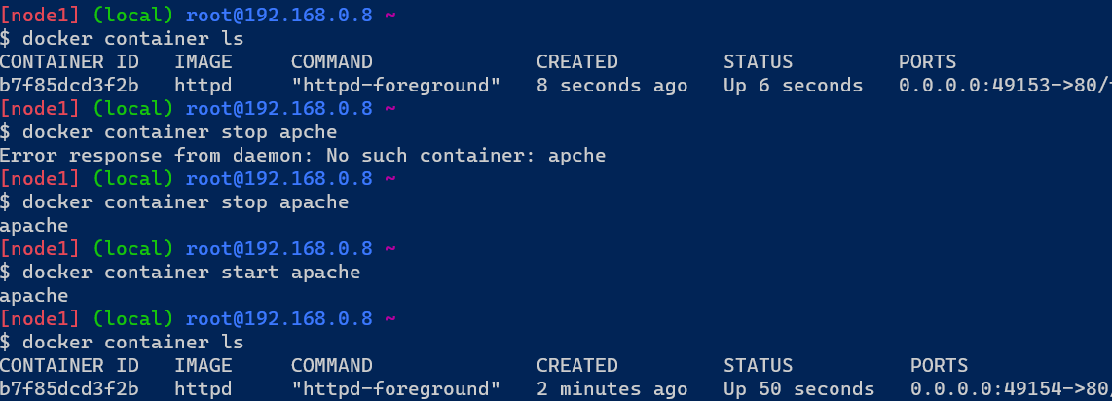

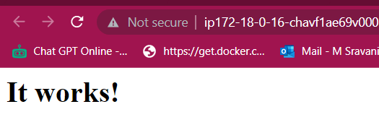

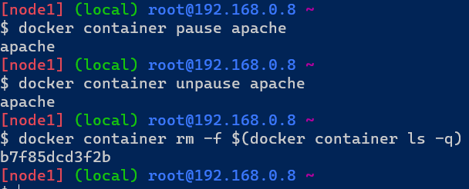

### **spring petclinic**

We need to run this application

Jdk 11

Jar file

For jdk 11 go to docker hub and search openjdk

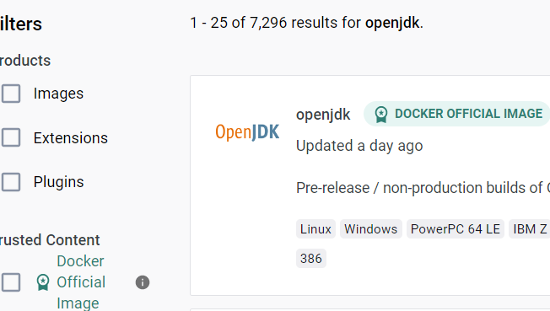

Select any on of the following

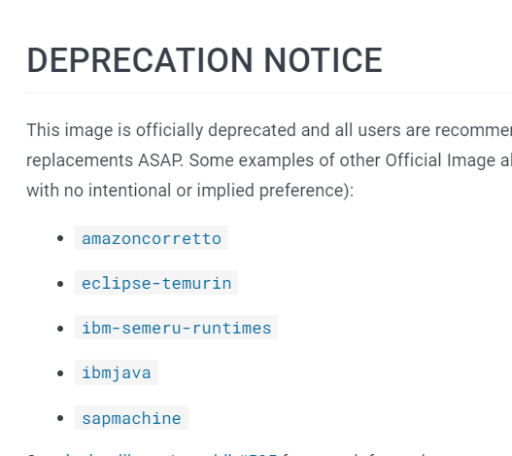

Open amazoncorretto and select the version

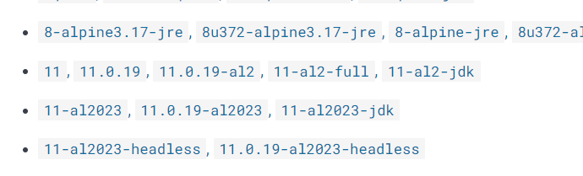

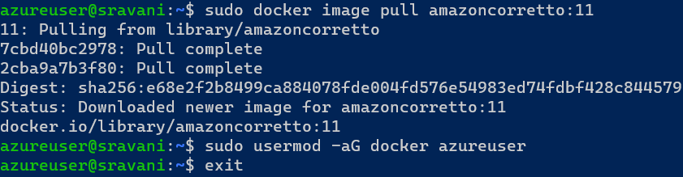

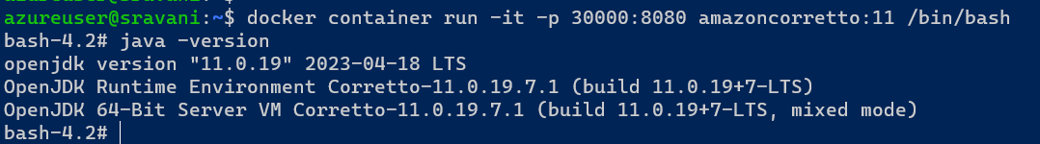



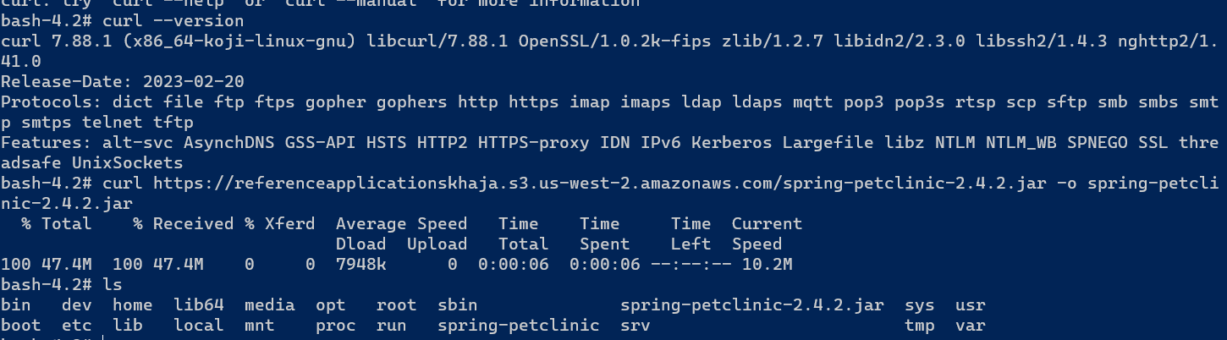

Give the port 8080 and 3000 on VM.

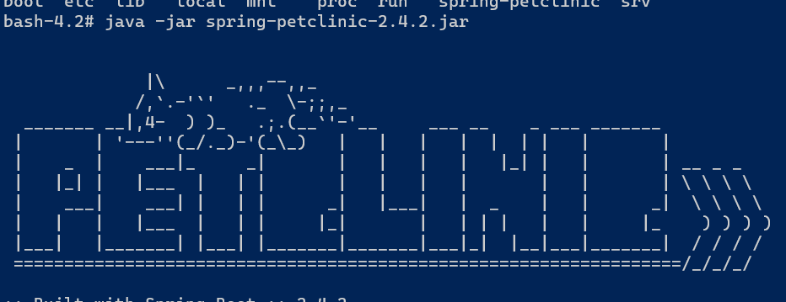

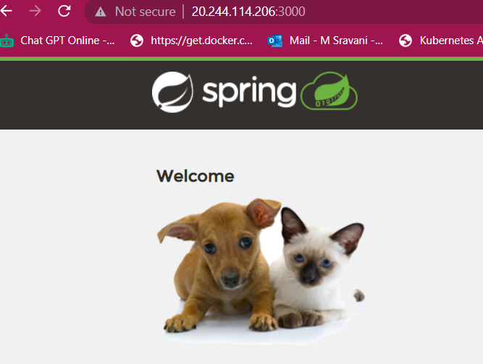

Now login to another terminal from same VM for running application.

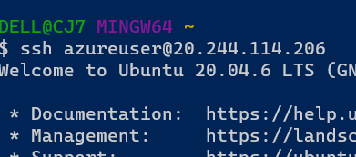

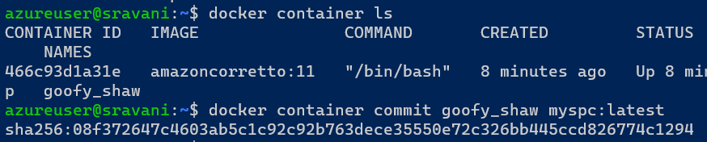

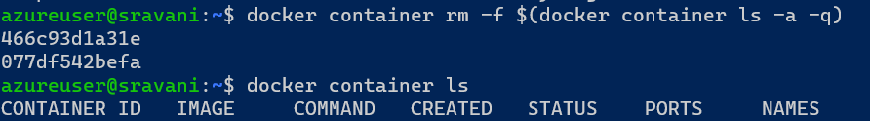

**Docker file based image build**

Work flow

Source code in git

Create a docker file to containerized application

Docker image build

Docker image in a local repo

Push

Docker registry

Docker

Docker container

**What is docker file?**

**Docker file is a simple text file that consist of instructions to build a docker image.**

FROM baseImage

LABEL key="value"

RUN command

CMD [ "executable" ]

ADD source dest

COPY source dest

WORKDIR /the/workdir/path

EXPOSE port

ENTRYPOINT [ "executable" ]

ARG name

ARG name=defaultValue

ENV key=value

VOLUME [ "/data" ]

HEALTHCHECK --interval=30s --timeout=30s --start-period=5s --retries=3 CMD [ "executable" ]

### **spring petclinic with docker file**



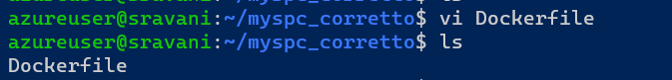

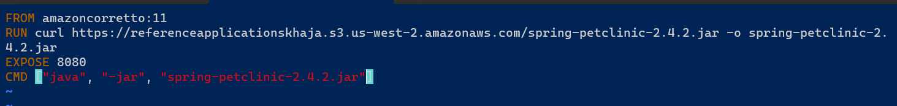

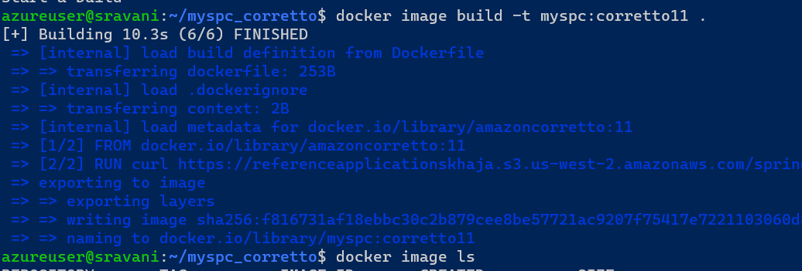

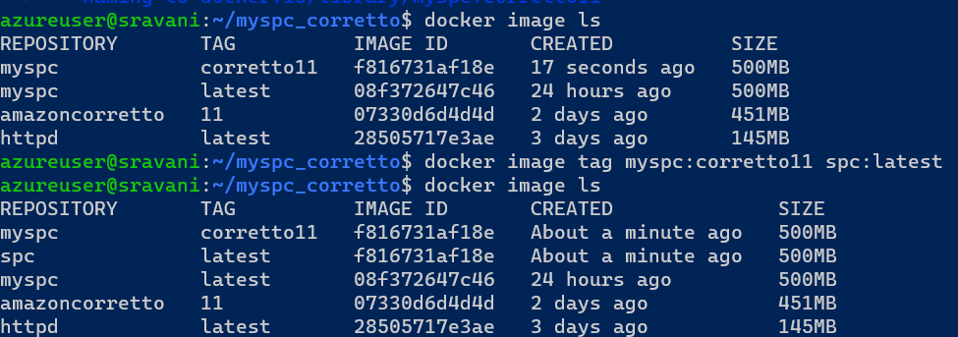

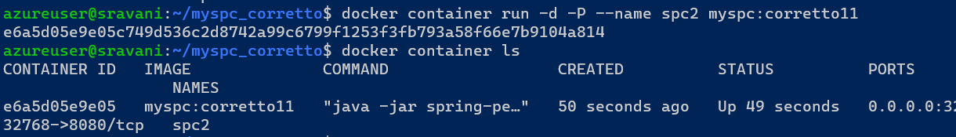

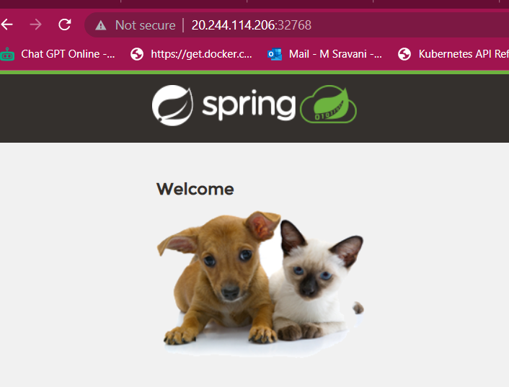

Another example

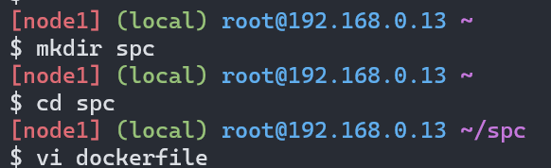

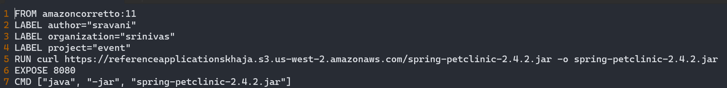

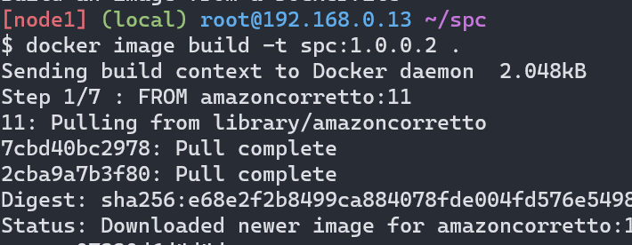

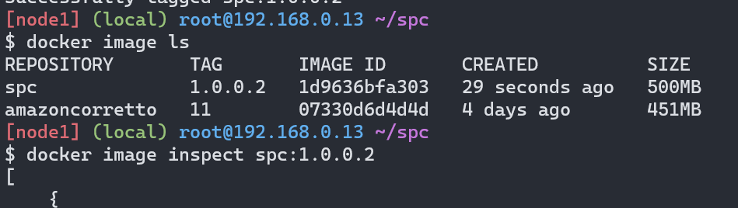

To check the labels what I gave

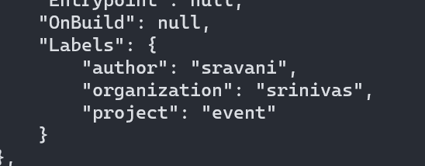

Add the ADD instruction in docker file

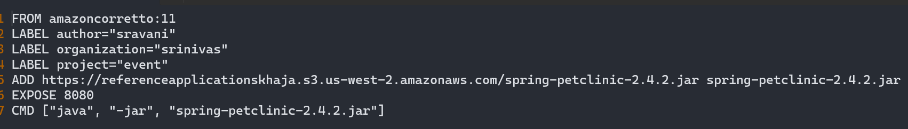

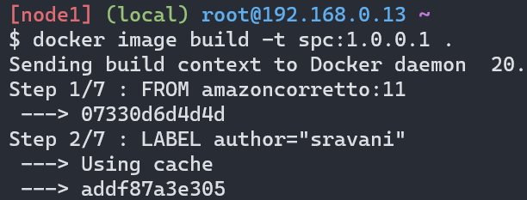

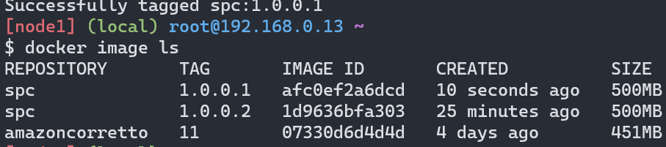

* ADD instruction can have sources
  + local file system
  + git repo
  + url
* COPY supports only local file system

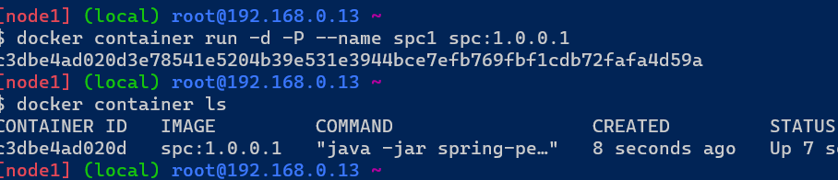

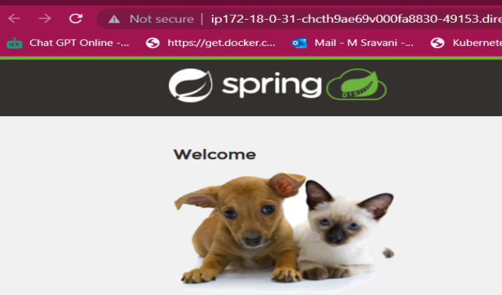

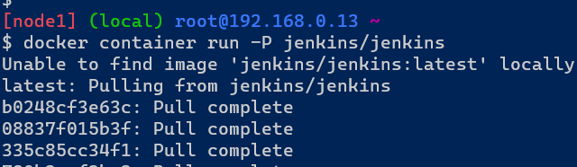

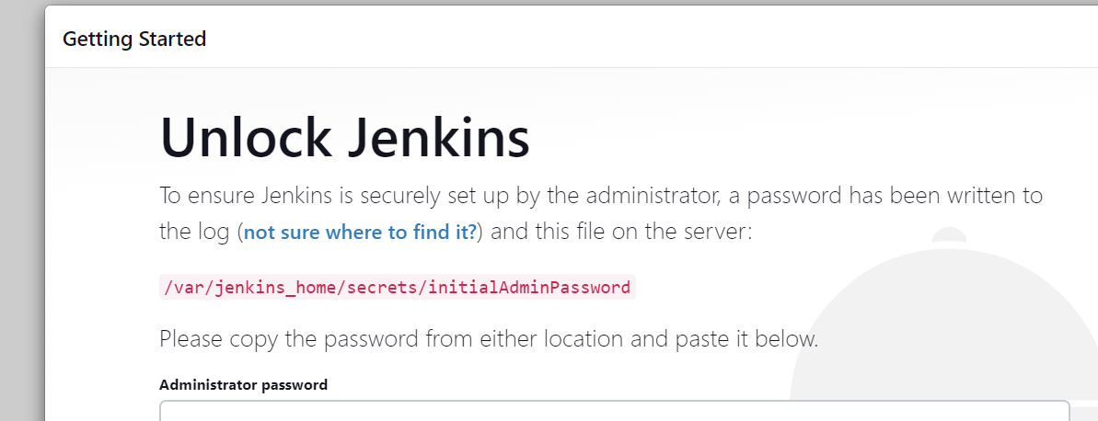

Enter the password from here

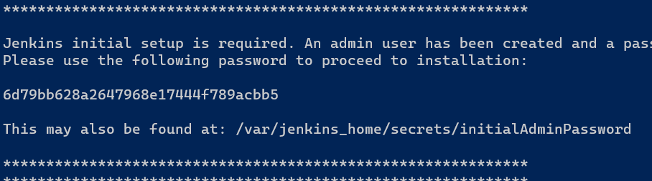

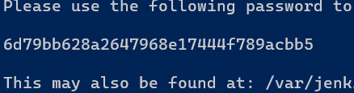

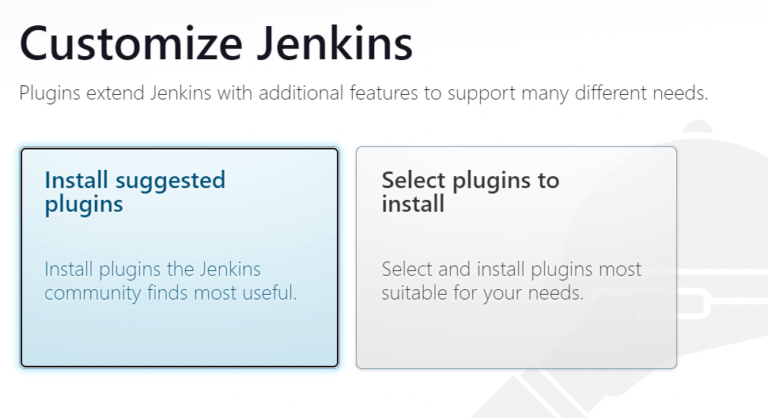

Now run in attached mode

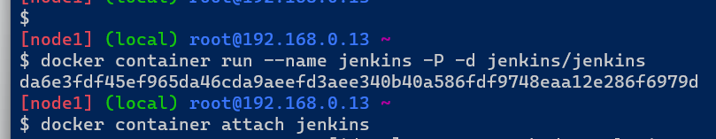

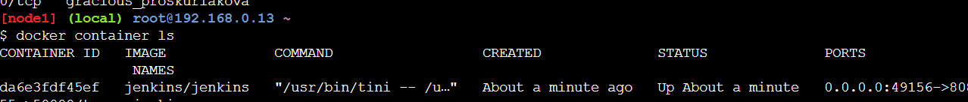







Click here install then it running the application

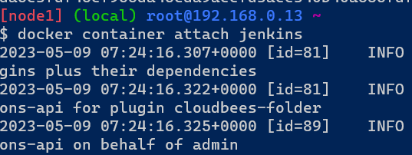

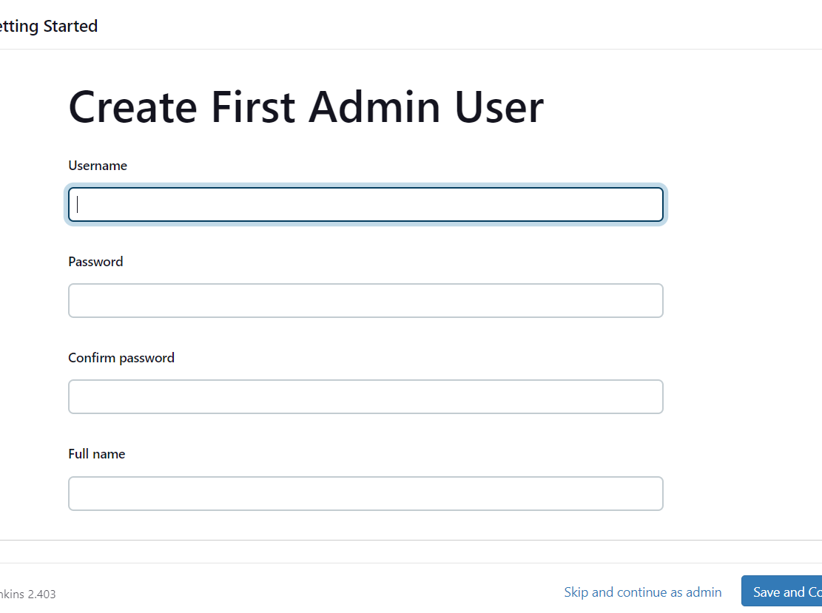

## dotnet application manual process

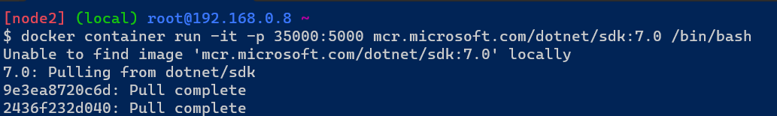

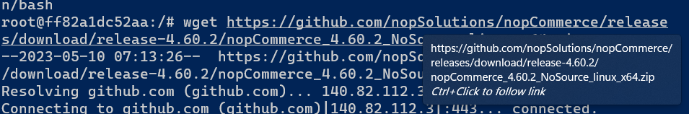

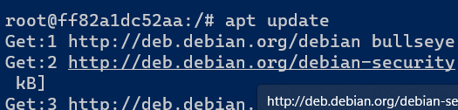

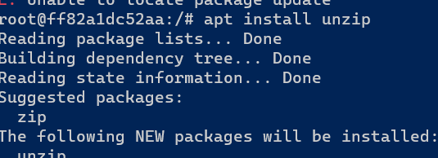

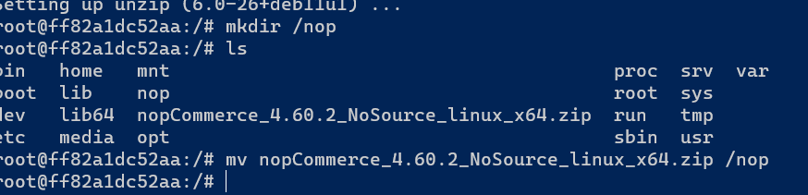



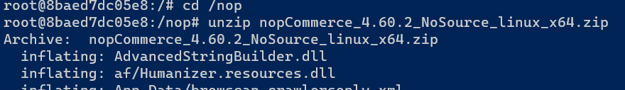

Create new folders two

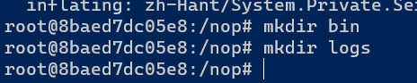

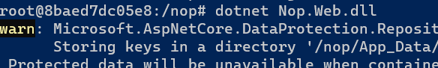

Now check the port 35000 it’s not working

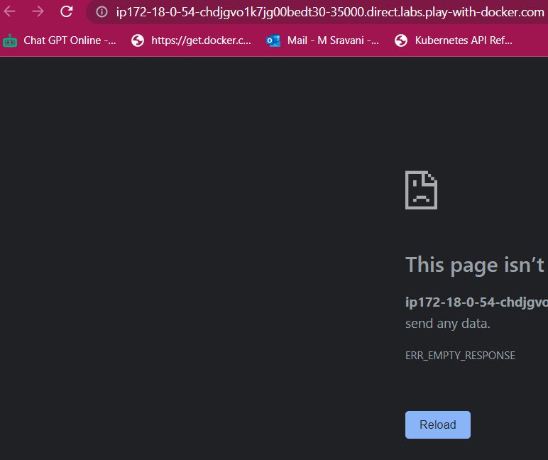





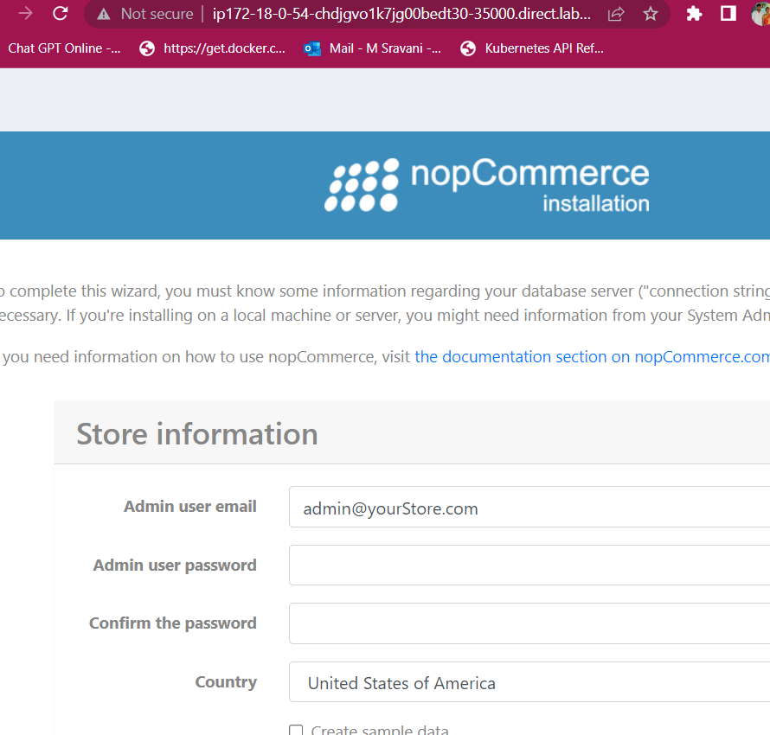

Run with docker file

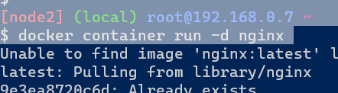

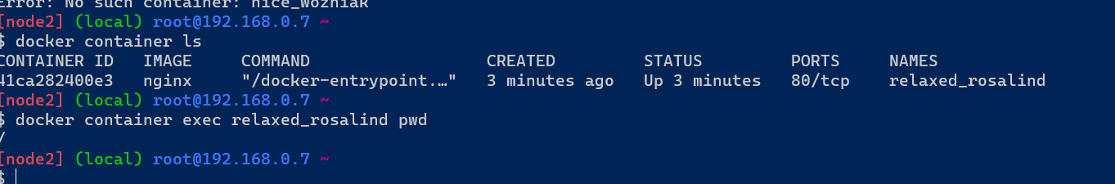

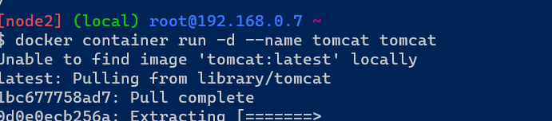

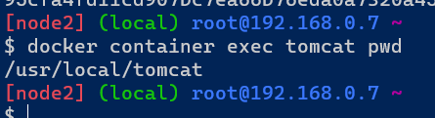

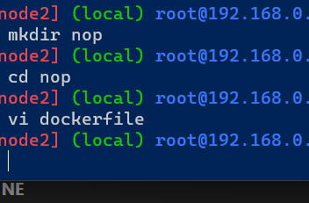

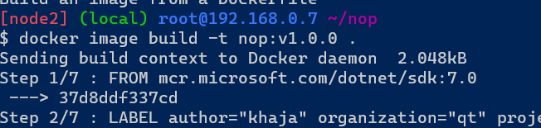

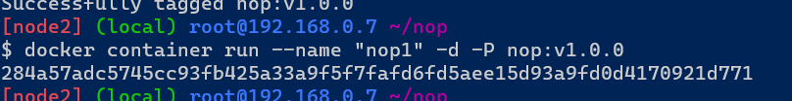

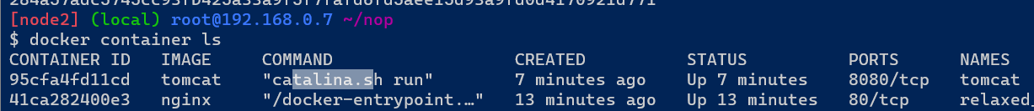

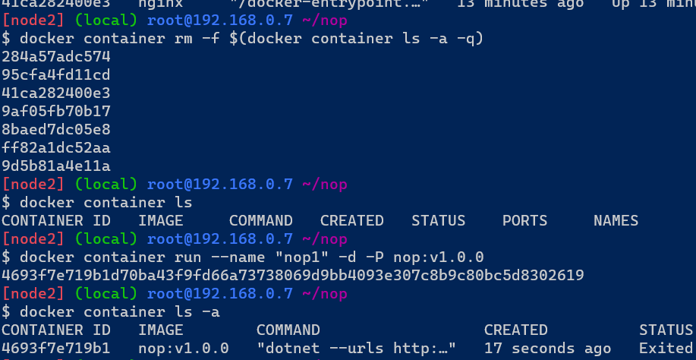

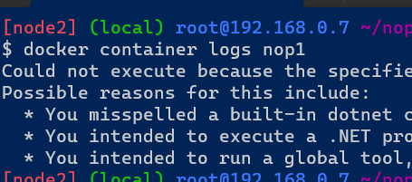

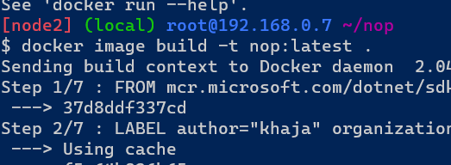

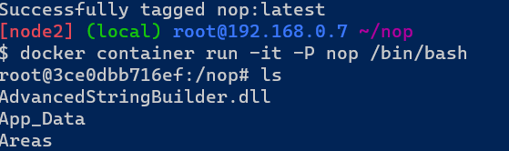

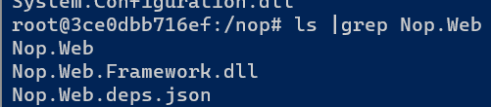

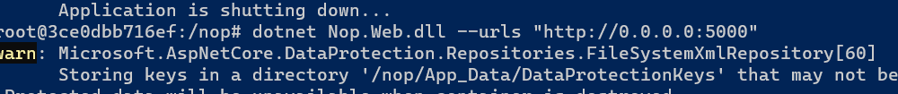

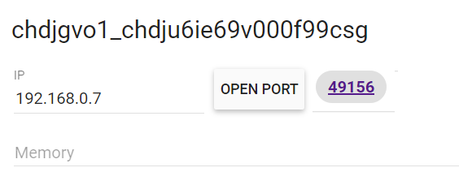





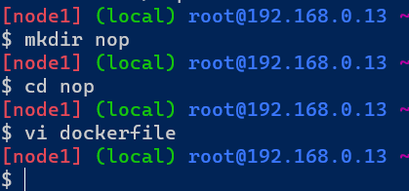

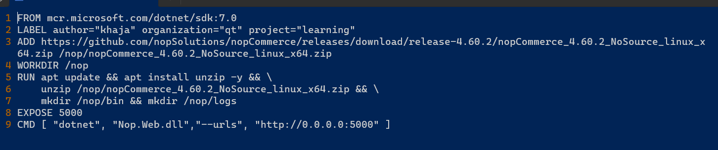

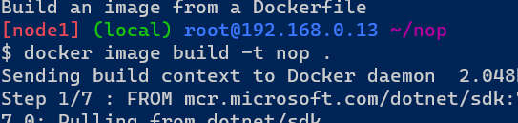

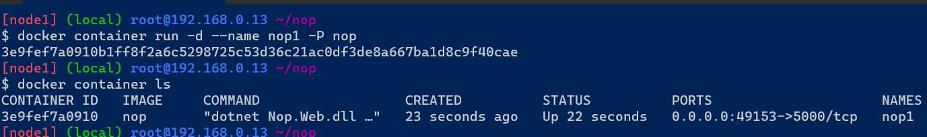

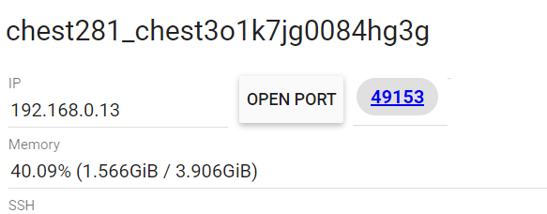

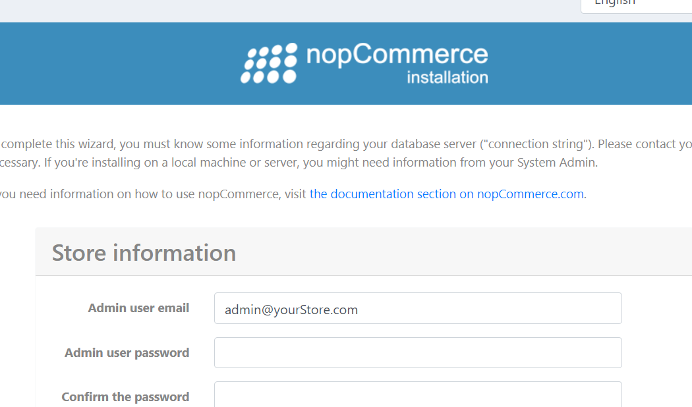

ENV instruction

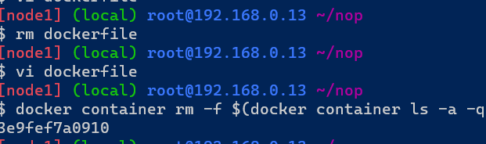

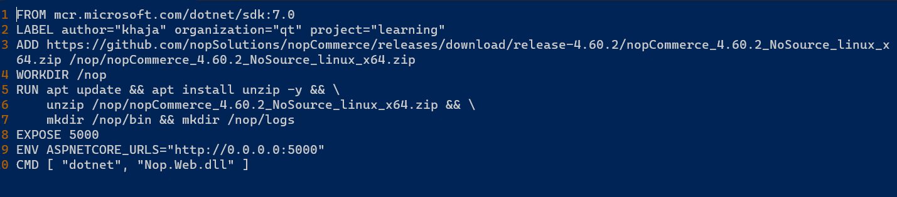

Remove previous image and build new image. To remove previous image

* docker image rm nop





Now check the port its working or not.

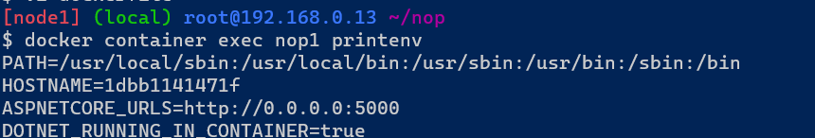

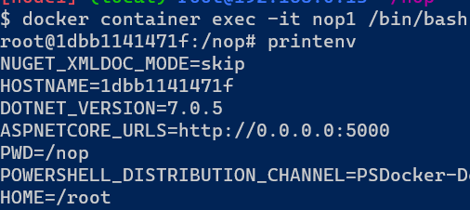

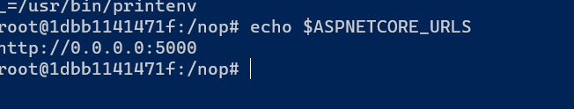

ARG instructions

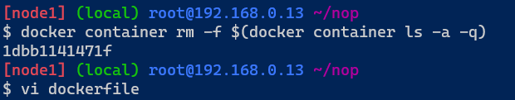

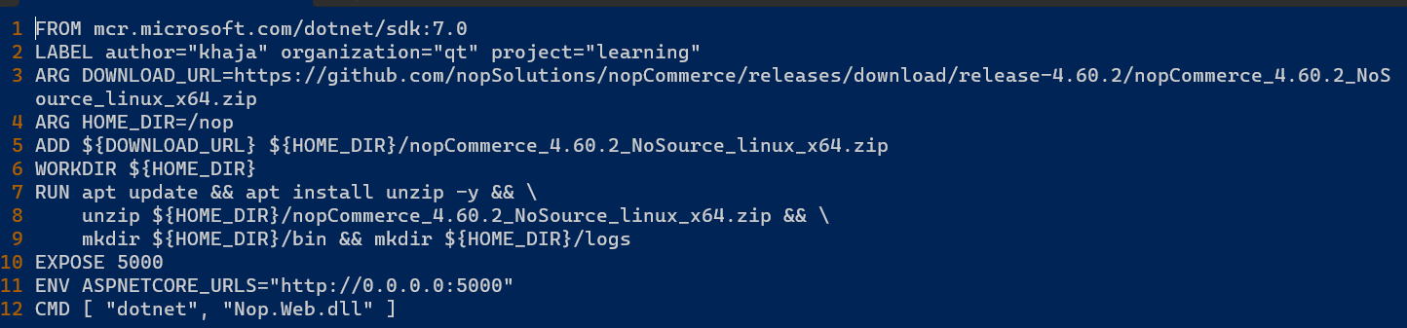

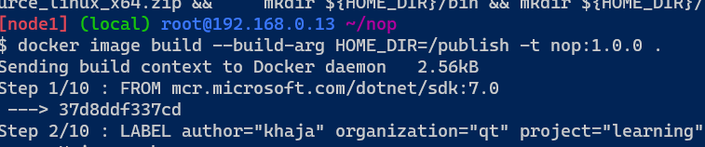

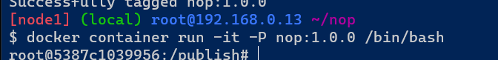

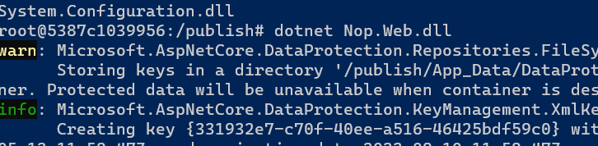

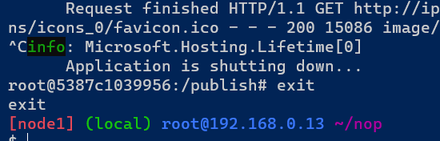

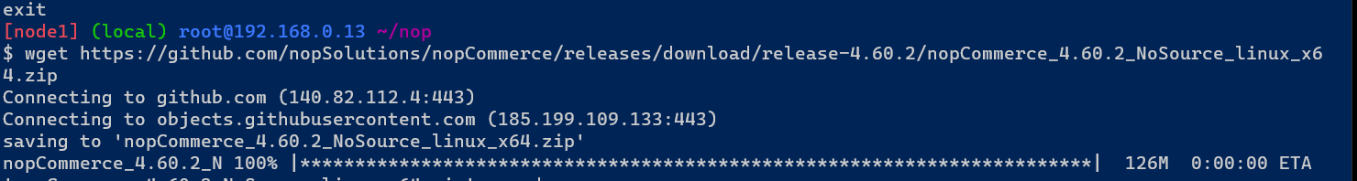

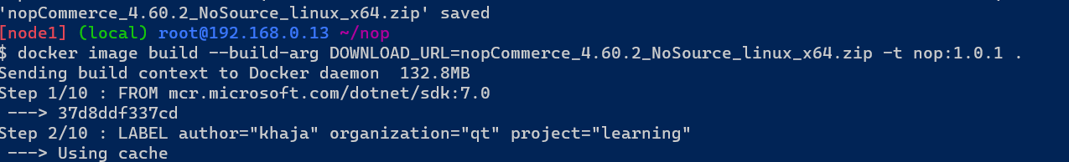

Add another ENV instruction

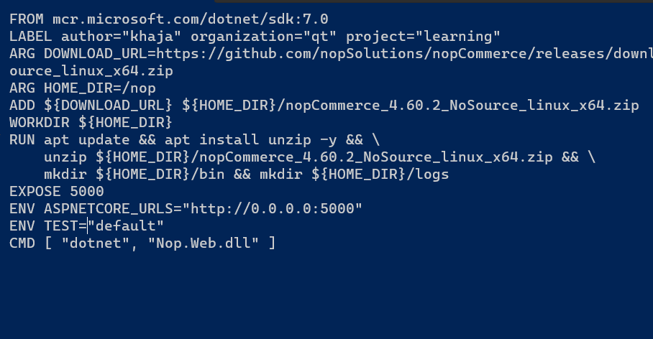

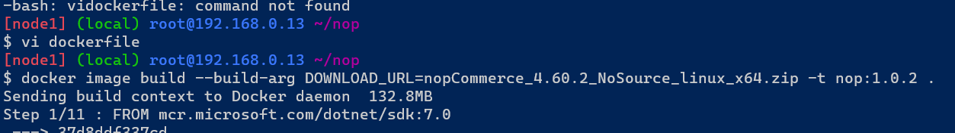

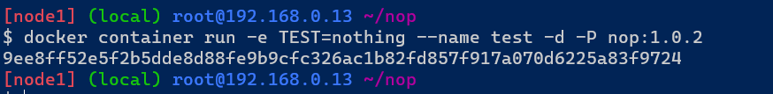

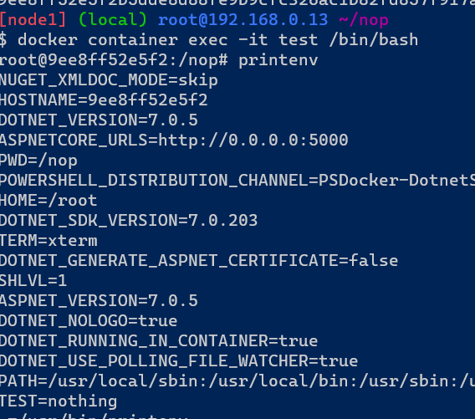

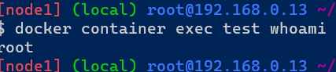

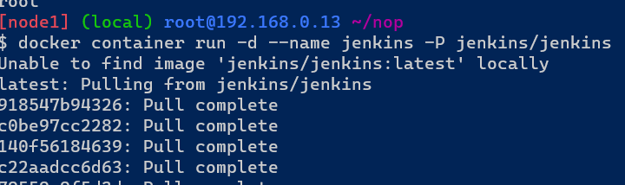

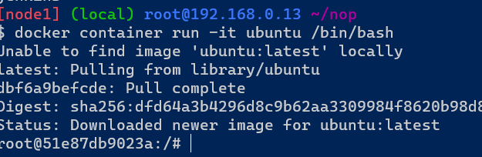

GAME OF LIFE Application

Docker file



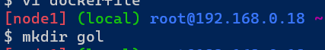

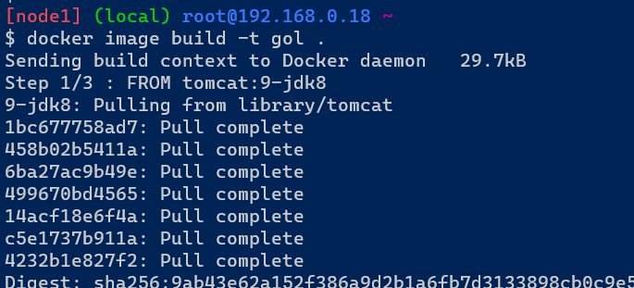

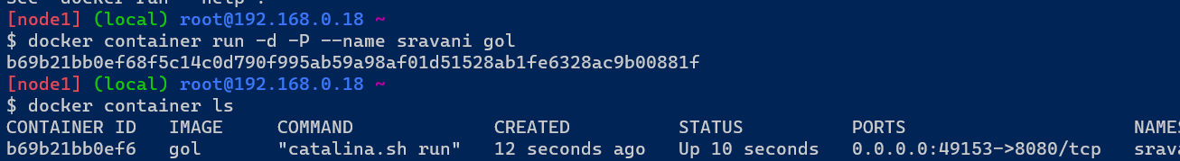

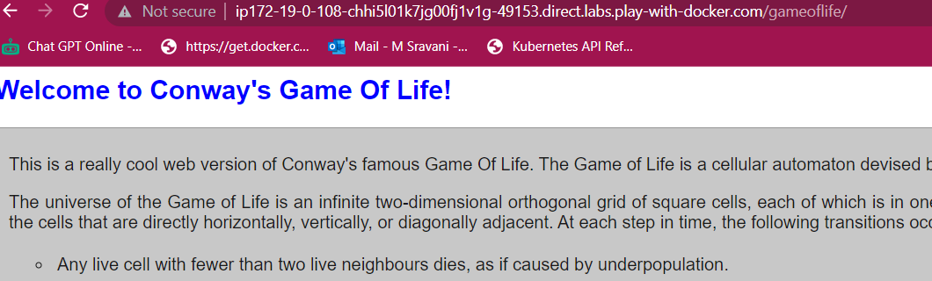

## **Image Layers**

* A Read write layer gets added to every container and image will have read layers
* Docker image is a collection of layers.

To see the layers in image

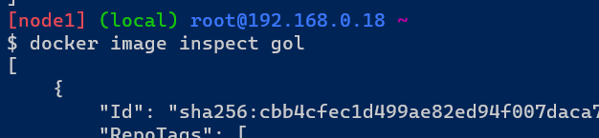

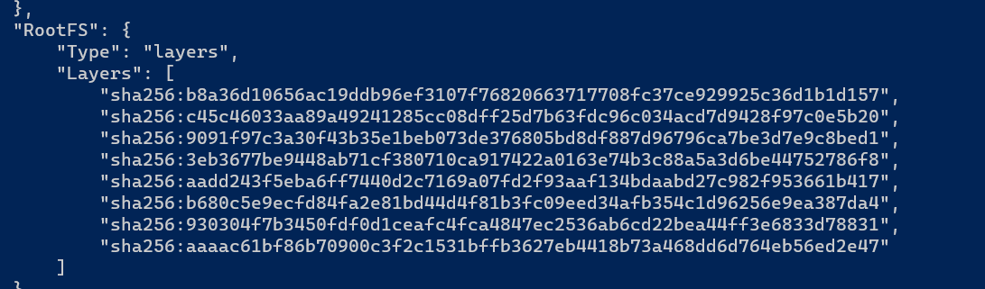

### **Stateful Applications and Stateless Applications**

* Stateful applications use local storage to store any state
* Stateless applications use external systems (database, blob storage etc) to store the state
* We need not do anything special if your application is stateless in terms of writable layer, but if it stateful we need to preserve the state.

Creating a MYSQL container



This is a stateful application it gives the information properly

To enter into MySQL container to expose the application

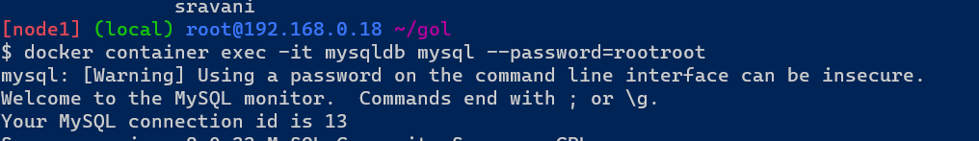

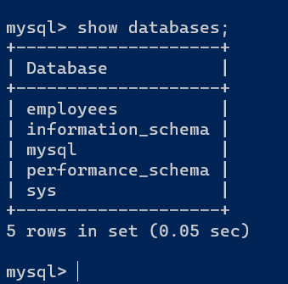

To create a table in MySQL

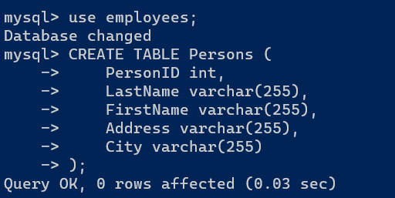

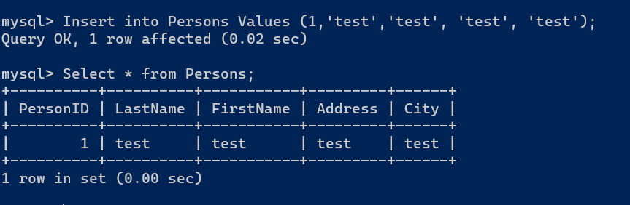

Now we observe the table. If the container will be deleted then we also loose data in the container.

To solve this problem we can fix the volumes to store the data if the container deleted also.

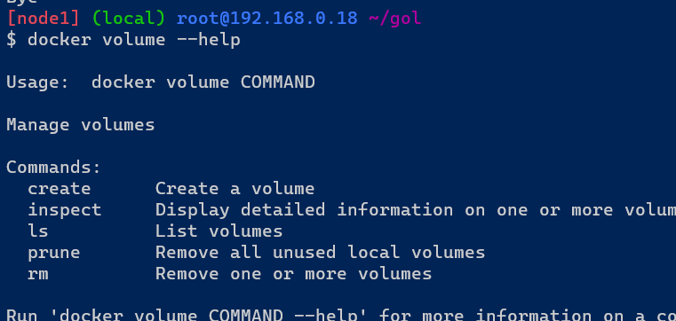

****Volumes****:

Stored in the host-file system managed by Docker (/var/lib/docker/volumes/ on Linux). Non Docker Processes should not modify the file system.

If writable layers are not available then volumes are also not there.

The volumes are three types

1. Bind mounts
2. Volume mounts
3. Tmpfs mounts

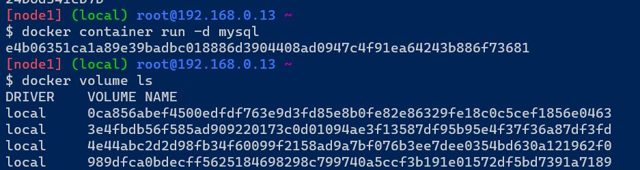

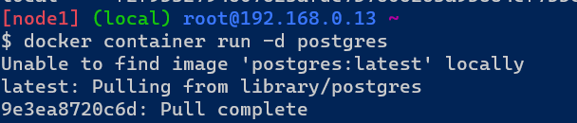

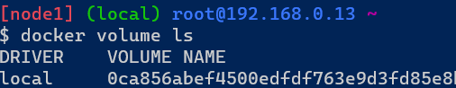

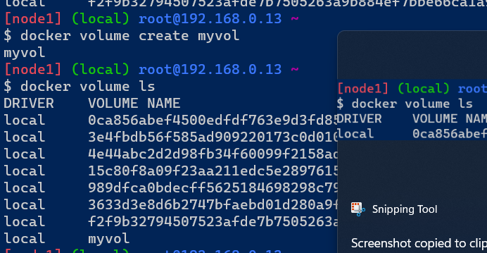

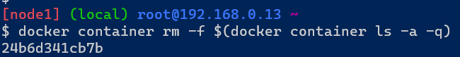

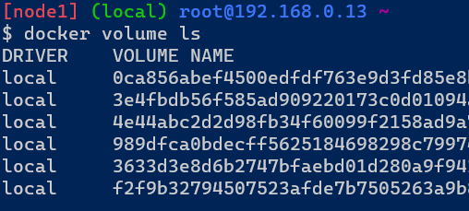

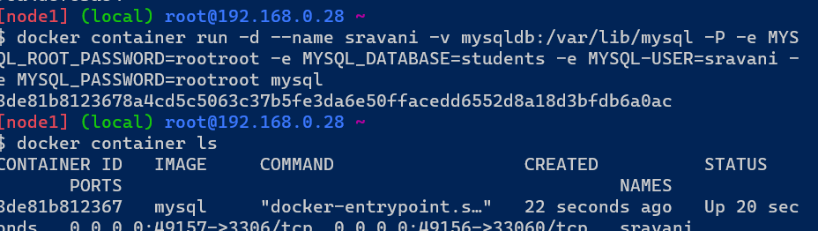

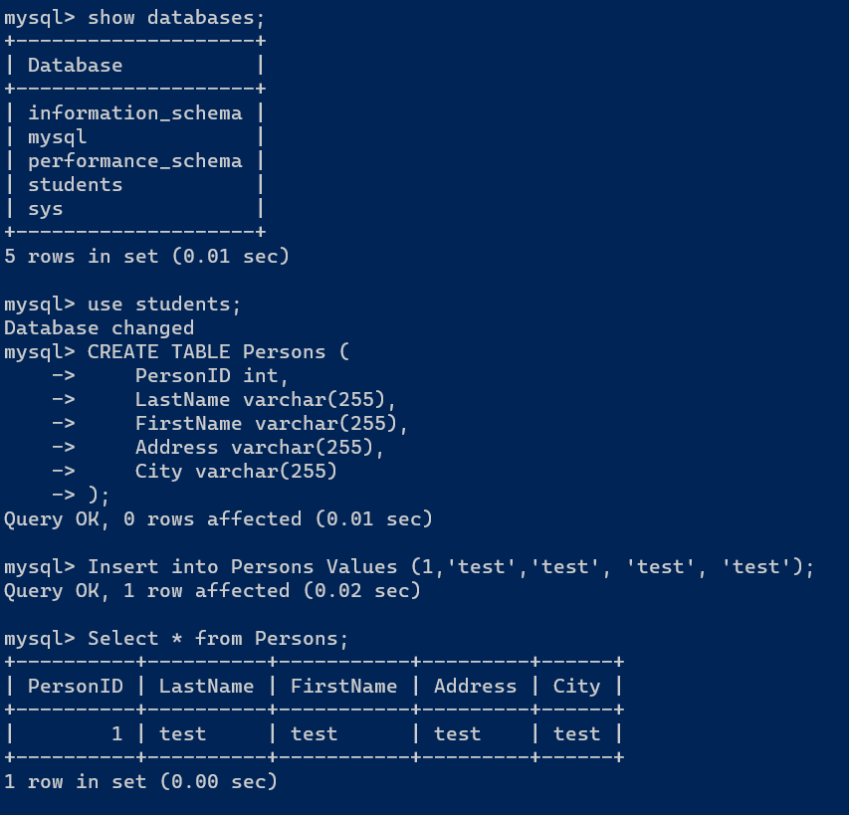

Now delete a container and create new container in another mode

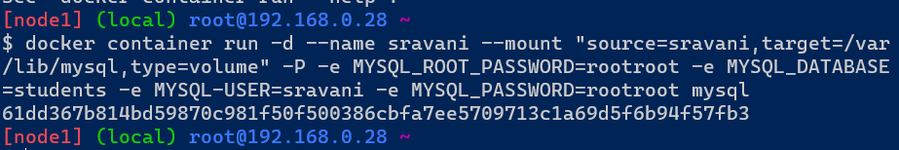

CREATE TABLE students ( PersonID int, LastName varchar(255), FirstName varchar(255), Address varchar(255), City varchar(255) );

Insert into students Values (1,'test','test', 'test', 'test');

Select * from students;

docker container run -d --name sravani --mount "source=sravani,target=/var/lib/mysql,type=volume" -P -e MYSQL_ROOT_PASSWORD=rootroot -e MYSQL_DATABASE=students -e MYSQL-USER=sravani -e MYSQL_PASSWORD=rootroot mysql

docker container exec -it sravani mysql --password=rootroot

docker container run -d --name sravani -v mysqldb:/var/lib/mysql -P -e MYSQL_ROOT_PASSWORD=rootroot -e MYSQL_DATABASE=students -e MYSQL-USER=sravani -e MYSQL_PASSWORD=rootroot mysql

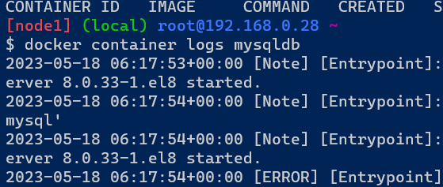

If the container exited when you create immediately then find out the problem by using logs command.

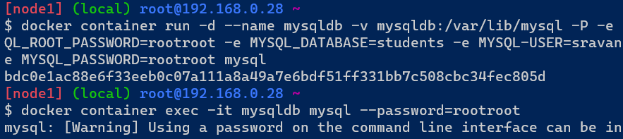

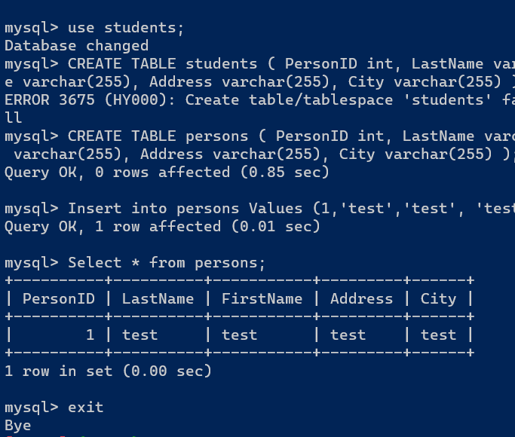

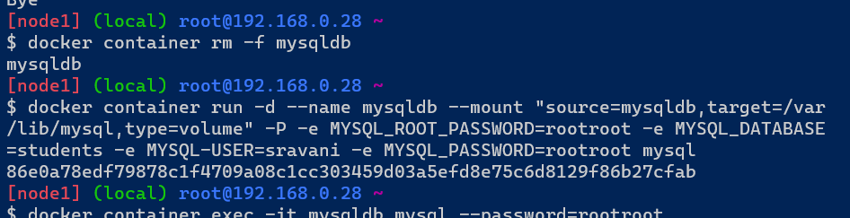

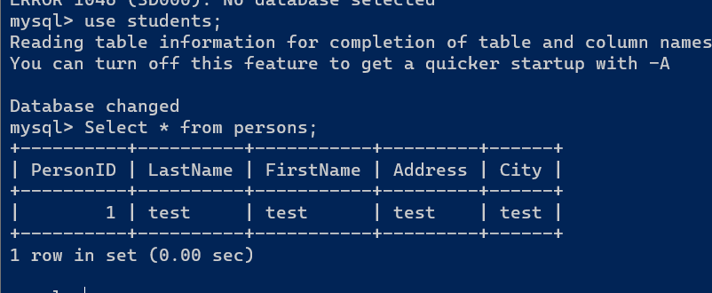

Now bind mode volumes

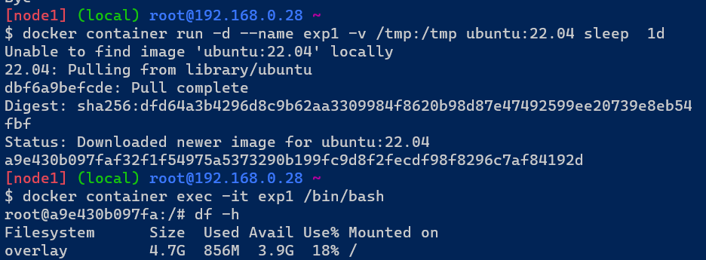

Now create files by using single command that is touch

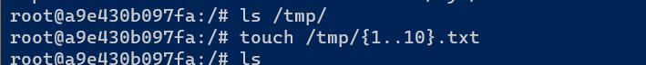

Now we check the files on docker play ground

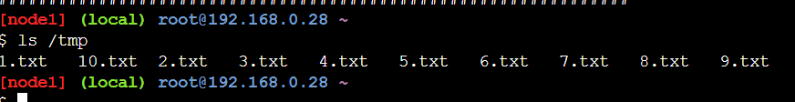

Bind mode is using only docker host and docker container having same folder then we use this mode.